CS 255 System Design Document Template

This template lays out all the different sections that you need to complete for Project Two. Each section has guidance to prompt your thinking. You will need to continually reference the interview transcript as you work to make sure that you are addressing your client’s needs. There is no required length for the final document. Instead the goal is to complete each section based on what your client’s needs are. Remove this note when you are finished, and replace all bracketed text with the relevant information.

UML Diagrams

UML Use Case Diagram
[In Module Six, you were asked to complete a use case diagram based on your system design. If you would like to make any adjustments to your diagram, please do so. Please insert your use case diagram here. Check to make sure that you included appropriate components and symbols and that your design meets the client’s needs.]
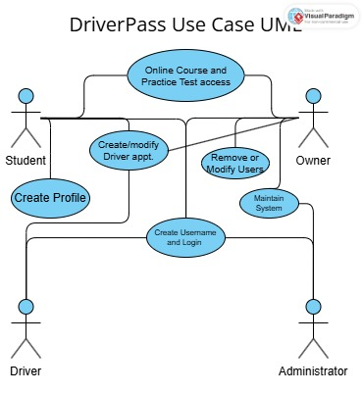

UML Activity Diagrams
[You were asked to choose two use cases and create two activity diagrams, one for each use case. Please insert both of your activity diagrams here. Check to make sure that you included appropriate components and symbols and that your design meets the client’s needs.]

Flowchart to show the steps to access a User Account through login
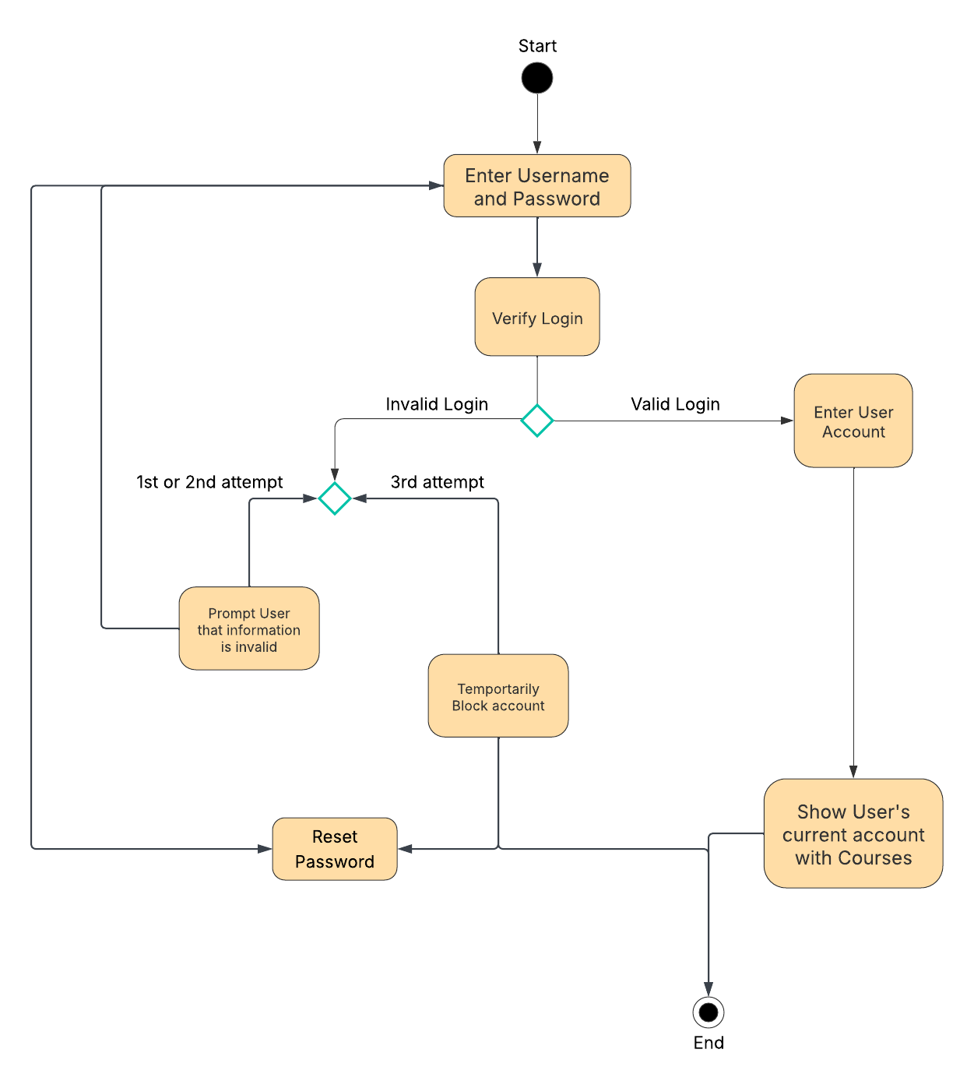

Flowchart to describe the purchasing from a User
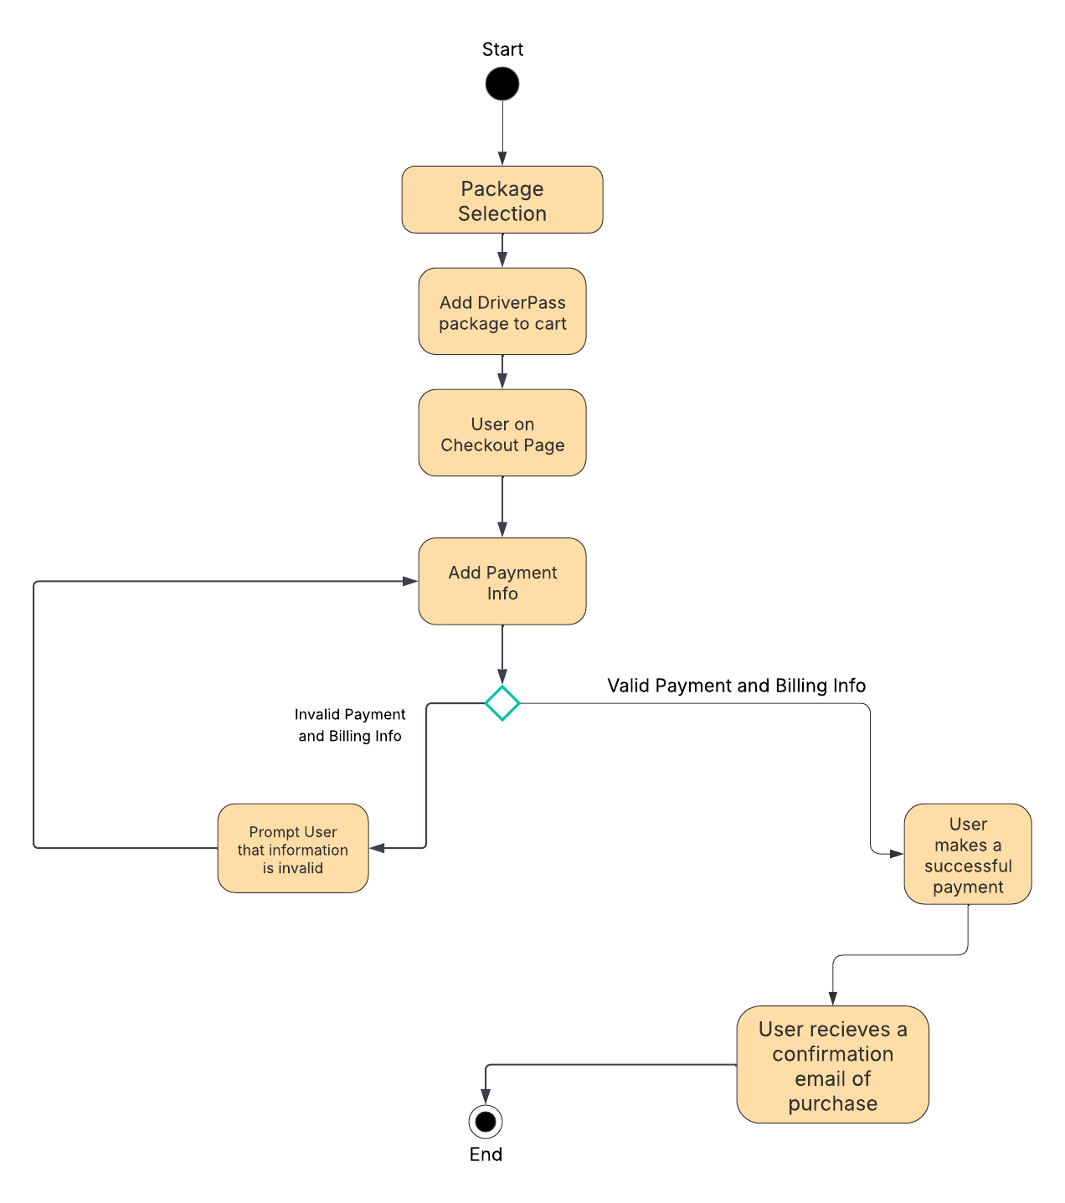

UML Class Diagram
[You were asked to create a class diagram based on the different classes and attributes needed for your system design. You are not required to include methods, but you may if you wish. Please insert your class diagram here. Check to make sure that you included appropriate components and symbols and that your design meets the client’s requirements.]

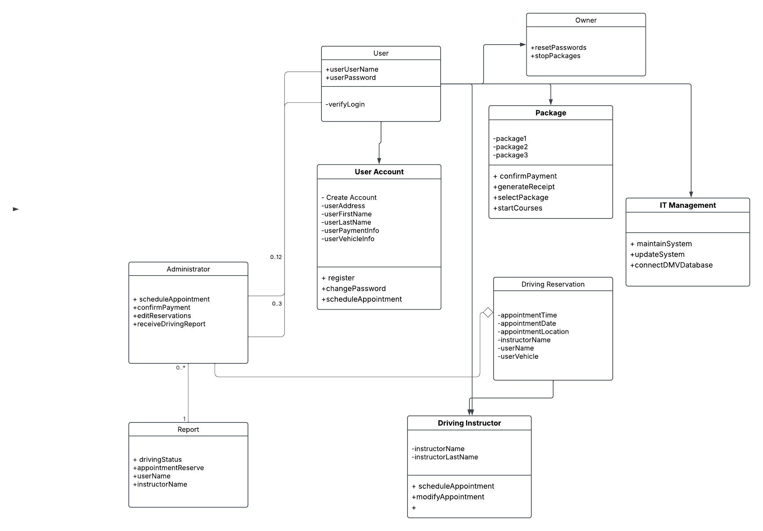

Technical Requirements
[Based on the diagrams you have created, describe the technical requirements of your system. These requirements should address the required hardware, software, tools, and infrastructure necessary for your system design.]
The technical requirements that are needed for the system design start with the hardware and software. The website needs to be launchable from a mobile device or a computer of some sorts so the hardware of the system should be able to adjust to the system a User is using. The website will be reliant on a cloud-based server. Having a solid and dependable cloud will ensure that the User and administrators will have the ease of knowing that there is level of security within the website. Another requirement that needs to be met is the payment requirements. Using a third-party payment like PayPal is something that needs to be considered when developing the website because payments are needed from the Users to begin their process on DriverPass. Last, the connection to the DMV database that updates and notifies when there are new policies needs to developed accordingly.

